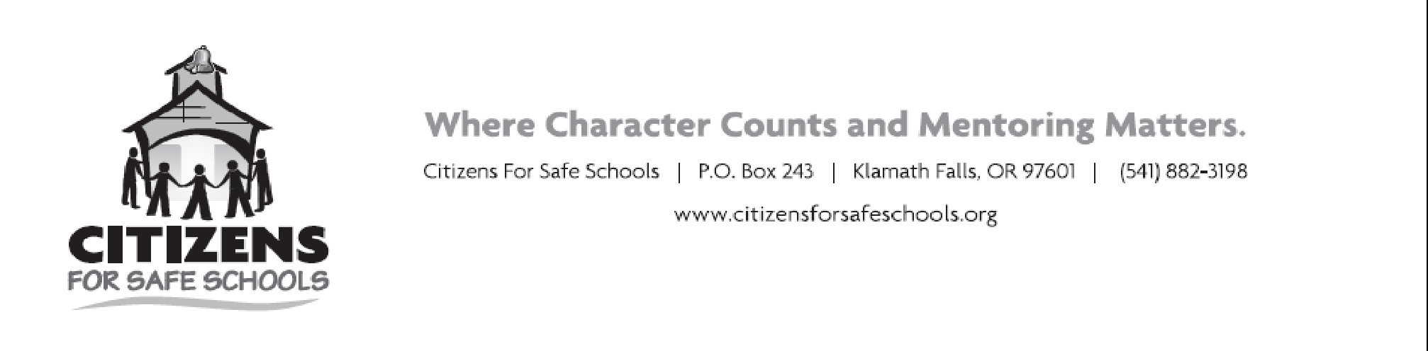

Greetings!

For 25 years, Citizens For Safe Schools, a 501 (c)3 organization, has provided youth development and mentoring for Klamath County’s “At-Promise” youth, leveraged over 850 volunteers with over 200,000 hours in that tenure, and secured over 20 million in grant and fundraising efforts to serve this community. We have one of the most active and broad-based partnerships of public and private supporters in Klamath County. Research, evaluations, and testimony confirm that this important work is producing safe, humane, non-violent young people. Our mission is to create a safe and drug free community where all children, especially those at risk for delinquency, academic failure or victimization have opportunities to build resiliency and character and all adults are empowered to help them.

Citizens For Safe Schools honors the universal human values crossing all divides called the 6 pillars of Character: Trustworthiness, Respect, Responsibility, Fairness, Caring, & Citizenship. We enthusiastically promote these pillars and character education through our annual CHARACTER COUNTS! American Youth Character Awards. We believe that recognizing youth and community educators for their strength of character is proactive prevention against cultures of bullying and acts of youth aggression by getting students to see the value in treating others with respect and creating safe climates at school.

Each year, with support from generous community sponsors, Citizens For Safe Schools honors six area students between the ages of 10-18 solely for their strength of character, and awards them $100 scholarships to be used for their future education. In addition, we recognize two community educators with our Character Builder Awards for their outstanding contribution to building socially, morally and ethically strong students. Winners will receive a $500 contribution to their character efforts within their classroom or program.

We are soliciting a request for sponsorship of these awards, all of which will directly go to the youth awardees or a fantastic educator’s classroom in Klamath County. If you would like to participate as a sponsor, please contact us with the amount of your donation, and/or mail a check to PO Box 243 KF 97601.

Thanks in advance for your consideration, and please feel free to phone 541-882-3198 or e-mail info@citizensforsafeschools.org for additional information, and view our website at www.citizensforsafeschools.org to learn more about our programs for youth in the Klamath Basin.

With sincere gratitude,

Robyn Sparkes
Executive Director
P.O. Box 243 | Klamath Falls, OR 97601 | 541-882-3198
www.citizensforsafeschools.org | www.facebook.com/citizensforsafeschools

